**Parcel — The Beast Bundler Package 🔥**

1. **What is Parcel/ Webpack ? Why do we need it?**

Parcel is a bundler package that combines a great out-of-the-box development experience with a scalable architecture that can take your project from just getting started to massive **production application**.

Those web application bundlers help you to pack the assets of your web application (code, images, packages etc.) into bundles so that the application can be served easily.

**2. What is an production ready app?**

An app that is minified, optimized, with clean console and bundled.

**3. What is `.parcel-cache`**

Beast space — it takes some space

The .cache folder (or .parcel-cache in parcel v2) stores information about your project when parcel builds it, so that when it rebuilds, it doesn't have to re-parse and re-analyze everything from scratch. It's a key reason why parcel can be so fast in development mode. I think committing it to git would be a bad idea - it would add a large number of (unnecessary) changes to your commit history, and it could easily get out-of-sync with the code that generated it.

**What is difference between `dependencies` vs `devDependencies`?**

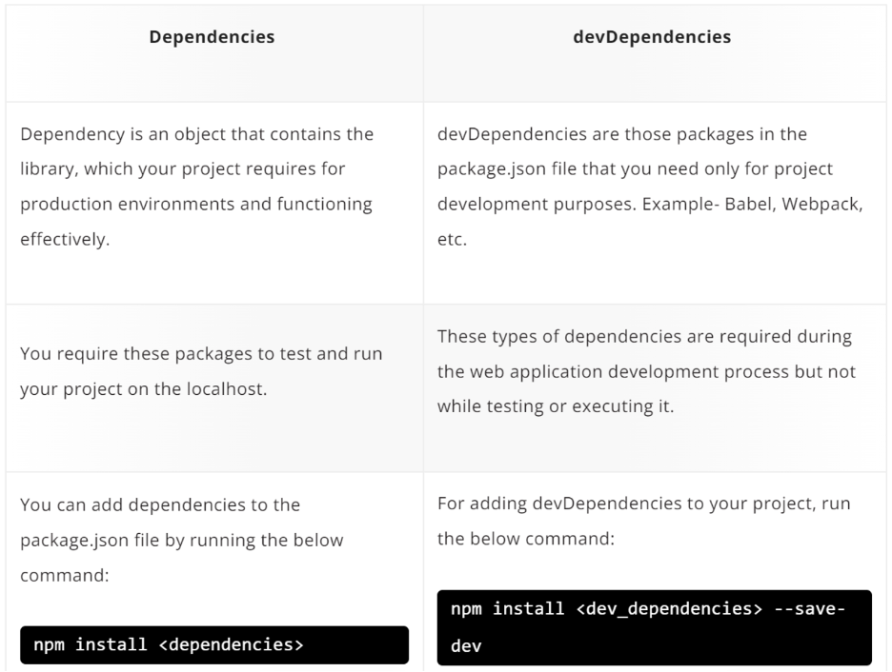

**4. What are some other bundlers that make the app production ready?**

a. Webpack

b. Vite

c. Snowpack

d. Rollup

e. Browserify

f. FuseBox

**Note:** The default create-react-app uses webpack bundler

**5. How to ignite the app using parcel?**

We want parcel to be in dev not prod, so use (-D)

[**parcel**  
*Blazing fast, zero configuration web application bundler. Latest version: 2.8.2, last published: 17 days ago. Start…*www.npmjs.com](https://www.npmjs.com/package/parcel)

Npm install -D parcel

Check package.json, you can find the installed package in devDependencies

"devDependencies": {  
 "parcel": "^2.8.2"  
 }

**6. What is `NPM`?**

**npm** is the world’s largest **Software Library** (Registry). **npm** is also a software **Package Manager** and **Installer.**

**npm** is installed with **Node.js.** This means that you have to install Node.js to get npm installed on your computer.

**7. What is `npx` ?**

The npx stands for **Node Package Execute** and it comes with the npm, when you installed npm above 5.2.0 version then automatically npx will installed. It is an npm package runner that can execute any package that you want from the npm registry without even installing that package.

**8. What is Caret and Tilde in package.json?**

· ~version **“Approximately equivalent to version”**, will update you to all future patch versions, without incrementing the minor version. ~1.2.3 will use releases from 1.2.3 to <1.3.0.

· ^version **“Compatible with version”**, will update you to all future minor/patch versions, without incrementing the major version. ^2.3.4 will use releases from 2.3.4 to <3.0.0. Upgrade itself - caret.

**9. What is the difference between `package.json` and `package-lock.json`?**

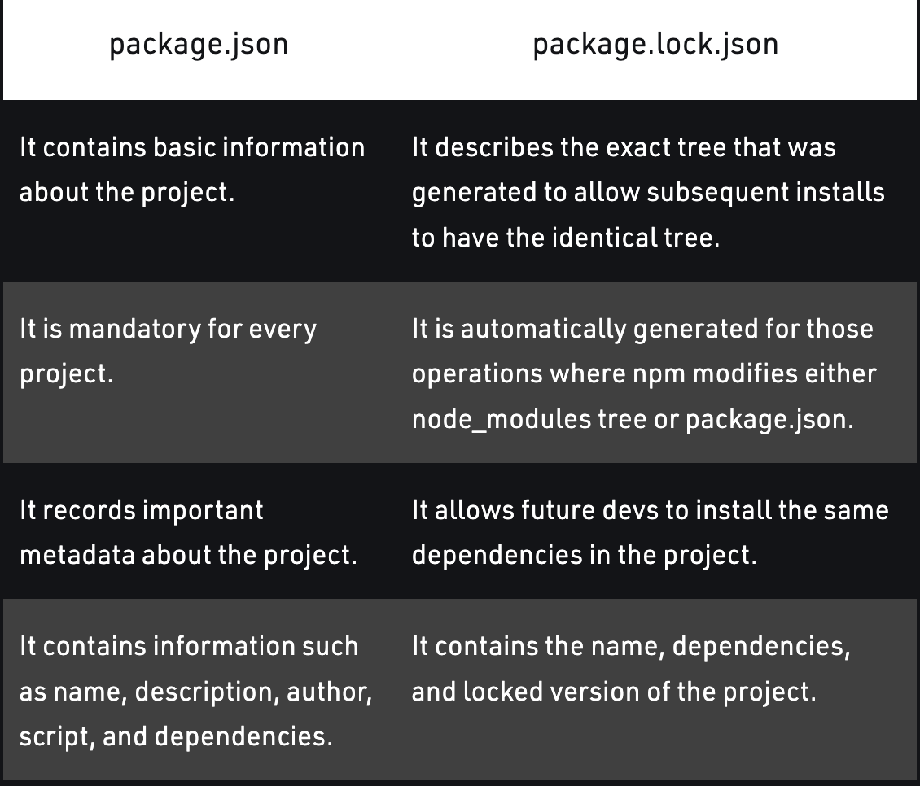

**10. Why should I not modify `package-lock.json`?**

Make sure you don’t change package-lock.json directly. That’s being handled automatically by NPM. It reflects changes made to package.json to package-lock.json and keeps it up to date.

However, this only happens if you use NPMs’ CLI to make changes. If you manually change package.json, don’t expect package-lock.json to update. Always use the CLI commands, like install, uninstall, etc.

**11. What is `node_modules` ? Is it a good idea to push that on git?**

Automatically Generated Files: node_modules and package-lock. json. When you first install a package to a Node. js project, **npm automatically creates the node_modules folder** to store the modules needed for your project and the package-lock.

It is not a good idea to push to git as the file is large.

**12. What is the `dist` folder?**

Folder to generate builds. Dist keeps files minified for us.

Npx parcel build index.html

**13. What is `browserlists`?**

Browserslist is **a tool that allows specifying which browsers should be supported in your frontend app by specifying “queries” in a config file**. It’s used by frameworks/libraries such as React, Angular and Vue.

**14. What are the Advantages of using Parcel?**

- Parcel is a bundler package (beast package)

- Npm init

- Parcel automatically updates the browser on each save ◊ Hot module reload [HMR]

- How parcel know we save the file ◊ File Watcher algorithm (C++) // so fast

- Minify

- Cleaning our code

- Compactible with older version of browser

- HTTPS on dev. Npm parcel index.html — https

- Does image optimization

- Caching while development

- Manage dev and prod build

- Super-fast build algorithm

- Put parcel-cache in git ignore

- Consistent hashing algorithms

- Zero config

- Tree Shaking — remove unwanted code

**15. What is Tree Shaking?**

Tree shaking is a term commonly used within a JavaScript context to describe the removal of dead code.

An unused export or import will be dropped.

**16. What is Hot Module Replacement?**

* Retain application state which is lost during a full reload.
* Save valuable development time by only updating what’s changed.
* Instantly update the browser when modifications are made to CSS/JS in the source code, which is almost comparable to changing styles directly in the browser’s dev tools.

**17. What is `.gitignore`? What should we add and not add into it?**

[**Gitignore Explained: What is Gitignore and How to Add it to Your Repo**  
*The .gitignore file is a text file that tells Git which files or folders to ignore in a project. A local .gitignore…*www.freecodecamp.org](https://www.freecodecamp.org/news/gitignore-what-is-it-and-how-to-add-to-repo/)

The git ignore file rule allows you to ignore a file you’ve committed in the past.